Machine Learning Concepts
Numpy Functions:
- arrange(): The arrange() function is used to create a sequence of evenly spaced values within a specified interval.
Syntax:
np.arrange(Start Val, End/ Stop Val, steps).

- reshape(): This function is used to convert the single dimension array into 2-dimension array or multi dimension.
- ravel(): This function is used to convert the multi dimension into Single dimension array.
- flatten(): This function is used to convert the multi dimension into 1-dimension array.
- transpose(): This function is used to convert the rows into columns.

Pandas :
What are Pandas?
- Pandas is a powerful python data analysis toolkit.
- It is open source
- A fast and efficient DataFrame Object for data manipulation.
- Reading and writing data structures and different formats such as :
    - Csv, tsv, txt, XML, JSON, ZIP, etc.
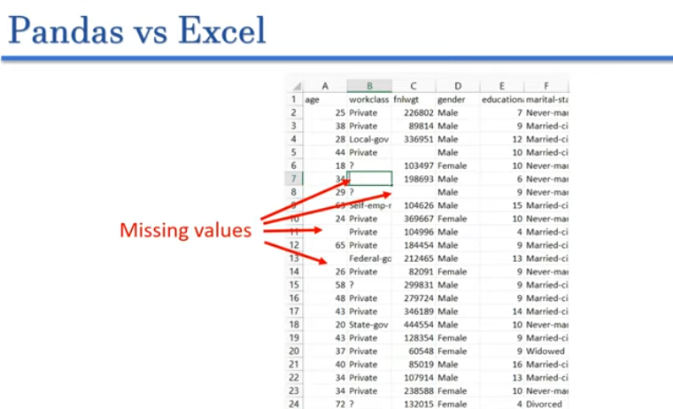

- To fill the missing values, if the millions of data to manually is impossible through Excell. So, we use the Pandas libraries.
- It is fast and an efficient in prepare and preprocess the data
Features of Pandas :
- By using pandas, we handle missing value
- Convert messy data into order format.
- We can do the Datasets (reshaping, slicing, indexing ).
Types of Pandas Data structures
- Series : Series mean Labelled Data
- DataFrame: is a two-dimensional, labeled, heterogeneous tabular data structure
    - Two-dimensional: Data arranged in rows and columns.
    - Labeled: Rows and columns have names (index and column labels).
    - Heterogeneous: Columns can store different data types.
    - Tabular: Data is organized in a table format.
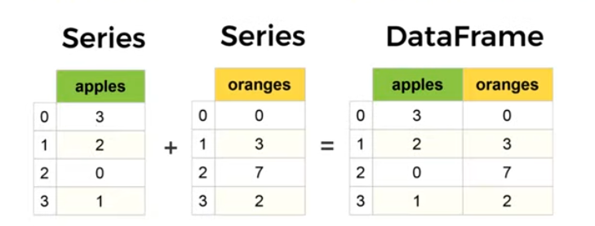

- Panel:

Pandas VS Numpy:
Numpy array is used for the implementation of Pandas data objects.

How to reads CSV file in Pandas?

